**UNIVERSITY OF MINNESOTA**

***Duluth Campus******Department of Anthropology,***  *228 Cina Hall*

***Sociology & Criminology***  *1123 University Drive*

*College of Liberal Arts Duluth, Minnesota 55812-3306*

*Office: 218-726-7551*

[*http://www.d.umn.edu/socanth*](http://www.d.umn.edu/socanth)

*Email: socath@d.umn.edu*

*3 September 2017*

Understanding Global Cultures Week 2

# Introduction to Anthropology / Orientation to the Course

# (cont.)

**Major Characteristics of Anthropology**

**[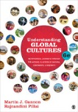](http://www.d.umn.edu/cla/faculty/troufs/anth1095/fstext.html#title)**

**I hope your first week with Understanding Global Cultures went well, and that it has been enjoyable, and that you are liking the readings.**

Each week as we go along I will send you a **memo about the highlights for the coming week, *usually* on Sunday**. The memos will talk about the main items and issues for the weeks, and they will also contain a few important reminders.

**The assignments due this week** are one of the important reminders, and they are **listed at the very end of each weekly memo**. They are also listed at the end of each Weekly Block in your **Moodle** folder.

These memos will also be available in your “Memos and Announcements“ section in Block 1 of your **Moodle** Folder (the top of “Main Course Page”), along with the other items. So if you prefer to go there for the information, that's fine. It will be the same on-line as in the e-mail memos.

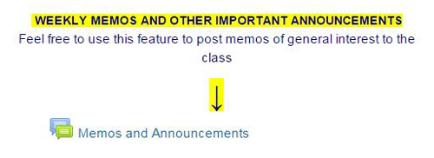

If you are curious about **the others in class, have a look at the "Introduce Yourself" Moodle Page from Week 1**—if you haven't already. And if you haven't already checked in on that, please do that. You'll find that at **“Introduce Yourself to the Class”**. Say "hi" to the others in class.

**[Introduce Yourself to the Class](https://ay17.moodle.umn.edu/mod/forum/view.php?id=194000')** f2017

If you are curious about me, more than you probably want (or ought) to know is available on the **[Meet Your Professor](http://www.d.umn.edu/cla/faculty/troufs/MeetYourProfessor.html" \l "title) page** <<http://www.d.umn.edu/cla/faculty/troufs/MeetYourProfessor.html>>. More that you or anyone needs to know is available, with some nice photos, at <<http://www.d.umn.edu/~troufs/anthfood/PowerPoint/af-meet_your_prof.pptx>>.

Last year one of the students seemed to especially like the part where the older folks in my home town of Winsted, MN, talk about the time I burnt the Town Hall by my dad's restaurant down (which I didn't, I only burnt half of the back side off.)

(If you need to upgrade **your PowerPoint viewer**, you can do that free at <<http://www.microsoft.com/en-us/download/details.aspx?id=13>>.)

Anthropology graduates, reflecting back on their time with us at UMD, suggested that it would be a good idea to tie the individual courses in the curriculum together a little more. So that’s what we’re going to do for much of the week, after we finish the **Orientation**.

**For the next four weeks** the class presentations will continue to focus mostly on **slide materials aimed at setting the basic analytic, theoretical and historical framework** for the course. This material should provide you with the **background and analytical tools** to help you with **your class** **Project**, and help you begin to make sense out of the topics that follow later in the course—a good deal of which will be provided *via* video—and towards the end of the semester with your class presentations.

Once you have mastered the basic information and conceptual framework relating to Understanding Global Cultures, we will have a look at other materials from around the world.

Some of the **slide sets** for this week are **fairly long, but bear with them as the programs as they provide important information**.

**A note on the slide formats:** Since at this point we do not know what software you are using on your computer, we offer the slides in two formats. We recommend you **first try "(.pdf)" pdf logo.png**, the **“Portable Document Format”** that is the open standard for document exchange. If you have problems with that format, please try **"(.pptx)"** pptx icon.jpg, Office PowerPoint 2007. It is unlikely that you will have problems with both of them, but if you do, please let me know: [troufs@d.umn.edu](file:///C:\\Documents%20and%20Settings\\troufs\\My%20Documents\\Web%20Sites\\www\\anthfood\\memos\\weekly%20memos\\troufs@d.umn.edu). When the materials are on your screen they should be running as a slide *show*. If you want or need to upgrade your software, you can [download the latest PowerPoint viewer free](http://www.microsoft.com/downloads/details.aspx?FamilyID=cb9bf144-1076-4615-9951-294eeb832823&displayLang=en), as well as [download the latest Adobe .pdf Reader free](http://get.adobe.com/reader/).

**This week we’ll also explore class projects a little bit.**

**For your Class Project, start with something *that you, personally, are interested in*, and we’ll work things out from there.**

**This Project is something with which you should be able to have *fun*.**

**It’s a good time to have at least a quick look at the information for your class project**, which you can find at <[http://www.d.umn.edu/cla/faculty/troufs/anth1095/gcproject.html#title](http://www.d.umn.edu/cla/faculty/troufs/anth1095/gcproject.html" \l "title)>. Your class Project is your Term Paper, plus a short “work-in-progress” Presentation.

|  |  |  |  |  |  |  |  |  |  |
| --- | --- | --- | --- | --- | --- | --- | --- | --- | --- |
| |  |  |  | | --- | --- | --- | | Demosthenes Practising Oratory Jean-Jules-Antoine Lecomte du Nouy (1842–1923) -- Wikipedia |  | Charles Dickens, 1842, Francis Alexander -- Wikipedia. | | *[Demosthenes Practising Oratory](http://en.wikipedia.org/wiki/File:DemosthPracticing.jpg)* (1870) |  | [Charles Dickens](http://en.wikipedia.org/wiki/File:Francis_Alexander_-_Charles_Dickens_1842.jpeg" \o "Charles Dickens, 1842 Francis Alexander (1800-1880) Wikipedia) (1842) | | **[Details of Presentation](http://www.d.umn.edu/cla/faculty/troufs/anth1095/fspresentations.html" \l "title)** |  | **[Details of Term Paper](http://www.d.umn.edu/cla/faculty/troufs/anth1095/fsterm_paper.html" \l "title)** | |

Your ***[Informal](http://www.d.umn.edu/cla/faculty/troufs/anthfood/afterm_paper.html" \l "projectstatement)* [Project Statement](http://www.d.umn.edu/cla/faculty/troufs/anthfood/afterm_paper.html" \l "projectstatement)**, or Project Proposal, is due by the end of Week 4, **Saturday, 23 September 2017**. Basically that’s a short *informal* summary personal statement of what you are interested in doing, how you think you might go about it, and what resources you are thinking about using. It can be as simple as the following:

“For my project I’m thinking about X, or Y, and these are the items I’m thinking about using [add short list]. This is why I’m interested in this/these project(s) [add your reason(s)]. . . .

It is an ***informal*** statement. A more formal statement will come later on (in Week 6).

If you have trouble getting started on that—“getting started” basically means picking a topic—let me know and I’ll help you work out an interesting topic.

**Major Due Dates** are listed at

<[http://www.d.umn.edu/cla/faculty/troufs/anth1095/gcdue-dates.html#title](http://www.d.umn.edu/cla/faculty/troufs/anth1095/gcdue-dates.html" \l "title)>

[including Term Paper / Exams / Extra Credit Papers . . . not including weekly Forum and Review assignments...]

Do you want a **list of all of the due dates for assignments?**

**Click on "Grades" in the upper-left-hand corner of yourMoodle screen.**

P.S. Weekly assignments are virtually all due by the end of the week in which they are assigned.

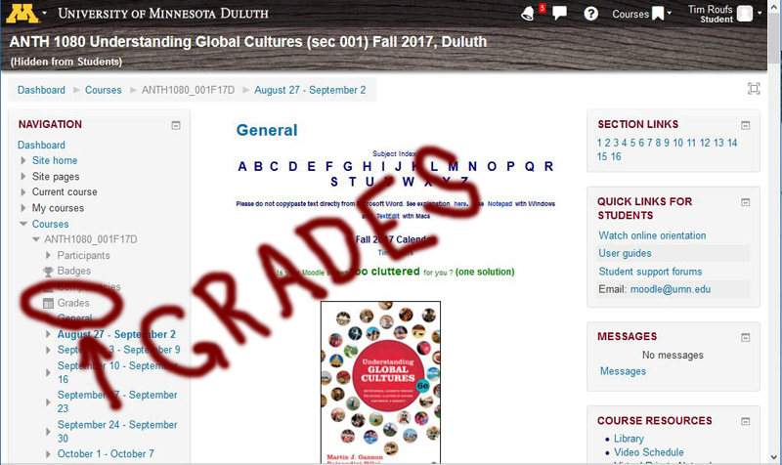

As I mentioned last week, **for the first part of the course** much of the material for the week will be presented in the form of text materials and slide materials. **In the second section** of the semester, once you have mastered the basic information relating to Understanding Global Cultures, we will look (generally comparatively, *cf*., Main Characteristics of Anthropology in Week 01) at a series of video materials from around the world. **The final section** will focus on your research projects.

**Yes, there are "an awful lot" of materials on-line** on the class **Moodle** and supporting WebSites.

**—maybe even too many!**

**Yes, there is a lot of information, no doubt about it,** and it can be confusing at first. It’s helpful when starting out to remember that **the required information for the course is contained *in the middle panel of your* Moodle *folder****.* The information in the sidebars and many of the links are just there should you find those interesting and/or helpful (especially for your Term Project).

**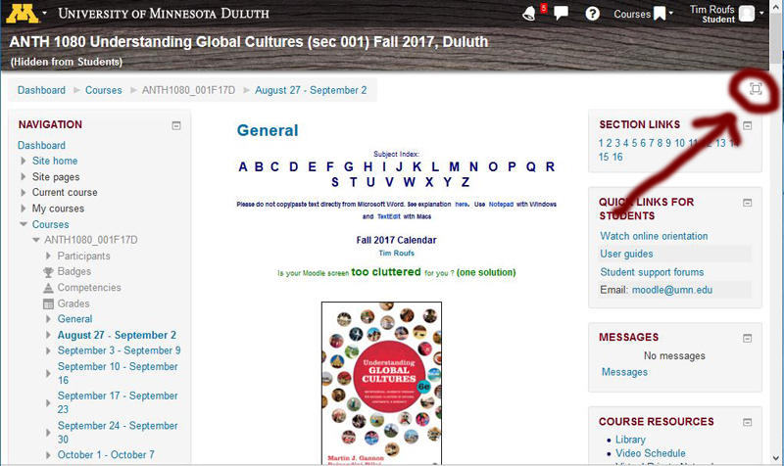**

**REM: Clicking on the little square symbol on the upper right-hand side of Block 1 (circled above) will clear your screen of the sidebar materials, and will focus on the Main Panel.**

**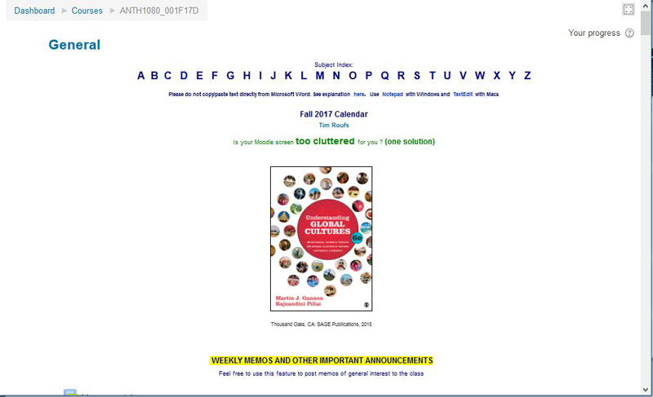**

**Please heed the earlier word of caution.** **Moodle** recommends that you **use the** **Firefox** **browser** (available free at <[http://firefox.com](http://www.mozilla.com/firefox" \o "Download Firefox browser)>). The Windows Internet Explorer (IE) occasionally will not display items on your screen. **These items will simply not be there on IE** when they are fine on **Moodle** or even on Chrome. Microsoft Word should likewise not be used to cut and paste things to **Moodle**; bad things can happen to your file if you do—randomly. Almost every time you are asked to enter text in **Moodle**, you will see the message, “Please do not copy/paste text directly from Microsoft Word. See explanation [here](http://www1.umn.edu/moodle/issues.html" \l "10" \t "_blank) <[http://www1.umn.edu/moodle/issues.html#10](http://www1.umn.edu/moodle/issues.html%2310)>.” Please pay attention to that request.

Your **Assignments and Activities listings** are available in the **Week 2 Block** of your **Moodle** folder.

Be sure to check the details of the **activities and assignments** of the week in your **Moodle** folder. With the Week 2 Activities we’d like to find out a little bit about your background and thoughts on Understanding Global Cultures*.* Detailed instructions are included in the *forum*.

**This week the Assignments and Activities include . . .**

*  **[Reading Assignments for Week 2](https://ay17.moodle.umn.edu/mod/page/view.php?id=194028)**
*  **[Pre Assessing Yourself](https://ay17.moodle.umn.edu/mod/feedback/view.php?id=194040)**
*  **[What Role Should the Pope Play in Global Cultures?](https://ay17.moodle.umn.edu/mod/forum/view.php?id=194042) (Due at the End of Week 2, Saturday, 9 September 2017)**

[Potential] **Sign up for a News-of-the-Day Report. News Features of Week 2 include . . .**

Tuesday:

[Thailand](http://www.d.umn.edu/cla/faculty/troufs/anth1095/Thailand.html" \l "title)

[Japan](http://www.d.umn.edu/cla/faculty/troufs/anth1095/Japan.html" \l "title)

Thursday:

[Saudi Arabia](http://www.d.umn.edu/cla/faculty/troufs/anth1095/Saudi_Arabia.html" \l "title)

**Vietnam**

**North and South** [Korea](http://www.d.umn.edu/cla/faculty/troufs/anth1095/Korea.html" \l "profiles)

**If you are still looking for a country to report on your “What’s in the News?” report, have a look at the list of countries scheduled . . .**

**[List of Countries / Regions by Week / Day](http://www.d.umn.edu/cla/faculty/troufs/anth1095/gc-in-the-news_schedule.html" \l "countries" \t "_blank)**

Basic information on the “What’s in the News?” features is available at . . .

[**News Report Basic Information**](http://www.d.umn.edu/cla/faculty/troufs/anth1095/gc_in_the_news_report.html#title)

**A little trivia for the week, for fun . . .**

**What is the smallest country [sovereign entity]**

**recognized by international law?**

([Answer](http://www.d.umn.edu/cla/faculty/troufs/anth1095/trivia/gctrivia_smallest_country.html#answer))

Your **Readings** and **Activities listings** are also available in the **Week 2 Block** of your **Moodle** folder.

If you have any **questions** right now, please do not hesitate to post them on the **Moodle** “QUICKMAIL”, "Messenger" or e-mail [troufs@d.umn.edu](mailto:troufs@d.umn.edu) , or stop in before or after class across the hall in Cina 215 [[map](http://www.d.umn.edu/maps/CinaH/)].

**Have a great Labor Day weekend.**

Best Regards,

Tim Roufs

<[http://www.d.umn.edu/~troufs/](http://www.d.umn.edu/%7Etroufs/)>